A KAZAKH NATIONAL UNIVERSITY

named after AL-FARABI

FACULTY OF LAW

DEPARTMENT OF CUSTOMS, FINANCIAL AND ENVIRONMENTAL LAW

FINAL EXAM PROGRAM

97080 Organization and planning of scientific research in the field of maritime and energy law.

7M04212 MARINE AND ENERGY LAW (BSU)

The course- 1
Semester -2
The number of credits – 5
The form of study – full-time, online

ALMATY 2023

The final exam program was compiled on the basis of educational program in the specialty 7M04212 Marine and Energy Law, by Ph.D., lecturer Teleuyev G.
Considered and approved at a meeting of the department of custom, financial and environmental law, dated October 31, 2023, protocol No 5.
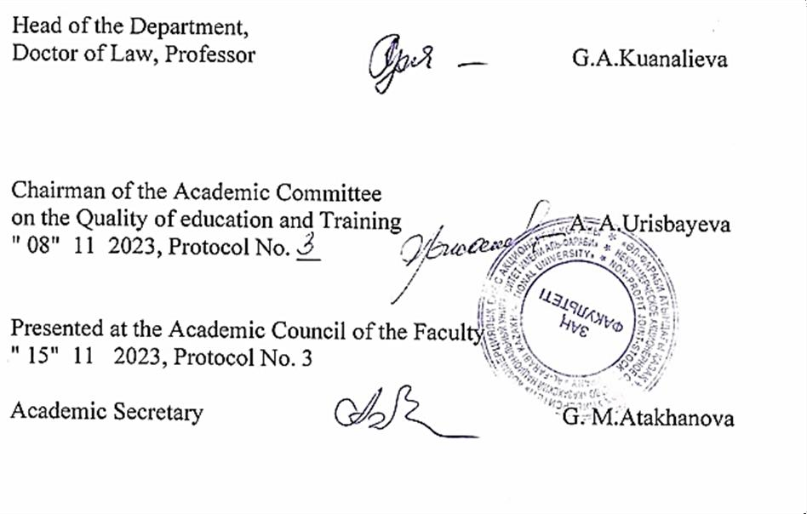

Introduction
Studying in the master's program is carried out in accordance with the State Standard of Compulsory Education of the Republic of Kazakhstan and academic policy, the study of the discipline ends with a final exam, which consists of passing the exam. Only undergraduates who have scored the appropriate points upon completion of the educational process in the discipline in accordance with the curricula and working curricula of the master program are allowed to the examination and final control. The exam is held on the dates specified in the Academic calendar and the working curriculum.
Undergraduates who have received an unsatisfactory grade, passing the final control for this period is allowed only with the payment of the loan and re-training. An appeal is possible. A graduate student who received an unsatisfactory grade on the exam results is registered for re-training by order of the university, if he received 25 points for the exam, then FX exam will be retaken. Documents for health reasons issued after receiving an unsatisfactory grade are not considered. Retaking an exam to increase grades is not permitted.
Final exam on “International legal problems of the status of the Caspian Sea” will be held in verbal form, online through the ZOOM platform, in according to exam schedule.

Description of the forms of conducting final control (exam).
- For admission to the exam, you must score at least 50 points for the current performance in the discipline (Level control 1, intermediate control, arithmetic mean, level control 2).
- Master students studying on a paid basis for admission to the exam should not have debts in tuition fees.
- The exam is conducted verbally. The form and schedule of the exam are indicated in the Univer system.
- During the exam, it is strictly forbidden to use or receive cheat sheets, mobile phones, smart watches and other means for transmitting information, communicate with other students and strangers and / or make other identification records in response.
- The use of additional information during verbal examination is strictly prohibited.
- The undergraduate does not have the right to open a ticket in front of the examining teacher to take the exam.
- The exam is held online via service on the corporate Microsoft Teams platform of Al-Farabi KazNU or in case of technical problems, external ZOOM resources. During the oral examination, video recording is

mandatory. The examination score can be canceled in case of violations this procedure by the undergraduate.
- At the end of the exam, the points scored by students within 48 hours are put on the certification sheet.

Guidelines for taking the verbal exam online
- Final control (exam) will be held in the service on the corporate Microsoft Teams platform of Al-Farabi KazNU or in case of technical problems, external ZOOM resources. The process of passing a verbal exam by a student involves the automatic creation of an examination ticket, to which the student must answer verbally by the examination committee. During the verbal examination, video recording is mandatory.
- Duration of the exam: The preparation time is decided by the examiner or the examination board. The response time is decided by the examiner or the examination committee. Recommended 15-20 to answer all ticket questions.
- Exam tickets in IS Univer are generated automatically.
- 30 minutes before the start of the exam, ALL students of the group enter the video conference room organized by the teacher or members of the commission according to the link specified in the rules of the final exam (sent by the teacher / members of the commission in case of disruption of the video communication service).
- 30 minutes before the start of the exam, they check the possibility of entering the Univer.kaznu.kz system through any browser, but preferably through Google Chrome (in case of losing the login and / or password, the student must contact the curator-adviser before the start of the exam). After verification, they log out of the account pending an invitation from the commission.
- When the start time of the exam comes, the student, who is called by the commission, shows his identity card (identity card or passport. It is forbidden to take the exam by ID-card) on the camera. Includes screen sharing. Logs into your account in IS Univer goes to the "Exam Schedule" page selects the current exam - by clicking on the "Pass oral exam" button. After clicking on the link “Pass the oral exam” a window will open where the student will see the questions of his examination card. The student shows the screen with the ticket questions, reads them aloud. Transfers the display of the videoconferencing service to the camera and prepares for the answer and after preparation for the period of time set by the teacher or the commission answers the ticket questions.
- If for technical reasons (power outage, disconnection or low Internet speed) a student who has already opened his ticket is absent from the online exam for more than 10 minutes, then his answer will be canceled. The exam is postponed to another date in agreement with the Department of Academic Affairs.

- The examination committee and the teacher certify the participants of the exam. They put points in the final sheet in IS Univer. Time for setting points in the attestation sheet for the oral exam is 48 hours. Exam rules: To pass the testing exam, students must first familiarize themselves with all the requirements for conducting an oral exam.
All instructions are uploaded: https://drive.google.com/file/d/1u_TOKL2MZiJsE3EJjluDNNv_68WXb4rG/view? usp=sharing With the date and time of the exam, students must

Assessment policy:
Criteria-based assessment: assessment of learning outcomes in accordance with descriptors, checking the formation of competencies (learning outcomes) at intermediate control and exams.
Examination answers are evaluated on a 100-point scale, taking into account the degree of completeness of the undergraduate's answer:
Grade | Criterias
Excellent | 1. Correct and complete answers to all theoretical questions are given; 2. Completely solved practical task; 3. The material is presented correctly in a logical sequence; 4. Demonstrated creativity.
good | 1. Correct but incomplete answers to all theoretical questions are given, minor errors or inaccuracies are made; 2. The practical task was completed, but a minor mistake was made; 3. The material is presented correctly in a logical sequence.
Satisfactory | 1. Answers to theoretical questions are in principle correct, but incomplete, there are inaccuracies in the wording and logical errors; 2. The practical task has not been fully completed; 3. The material is presented correctly, no logical sequence
Unsatisfactory | 1.Answers to theoretical questions contain gross errors; 2. The practical task has not been completed; 3. In the presentation of the answer, grammatical and terminological errors were made, no logical sequence
Letter grade | Digital equivalent | Scores in percentage (%) | Grade under traditional system
A | 4 | 95-100 | Excellent
A- | 3,67 | 94-90
B+ | 3,33 | 85-89 | good
B | 3,0 | 80-84
B- | 2,67 | 75-79
C+ | 2,33 | 70-74 | satisfactory
C | 2,0 | 65-69
C- | 1,67 | 60-64
D+ | 1,33 | 55-59
D- | 1,0 | 50-54

FX | 0,5 | 25-49 | unsatisfactory
F | 0 | 0-24

THEMES:
1. Social cognition and its peculiarities. The Concept of Methodology as a Theory of Scientific Cognition of Society.
2. Methodology of cognition of socio-political processes: essence, structure, subject, goal and objectives.
3. Comparative Characteristics of Sociological and Historical Cognition.
4. Sociological and historical approaches. Methodological principles.
5. The concept of research. Structure of the study of social processes. Program.
6. Description of social factors and interpretation (explanation) of social facts.
7. Social law as a basis for explanation and conclusion. Sociological and historical laws.
8. Use of research results.
9. Phenomenology. Neo-Hegelianism and Structuralism as Methodological Under- Moves.
11. Methodological approaches of M. Weber
12. The concept of scientific method. General Logical Methods of Cognition.
13. Analysis and synthesis. Abstraction and generalization.
14. Induction and its types. Deduction.
15. Analogy and modeling.
16. Scientific Research Methods: Construction of Theoretical Knowledge.
17. Scientific Research Methods: Construction of Empirical Knowledge.
18. Document Analysis as a Research Method.
19. Method of expert evaluation. 20. Survey and its types.
21. Observation as a method of research.
22. Method of Experiment in Sociological Research.
23. Methods of sociometry.
24. Measurement of social attitudes.
25. Choice of data collection methodology,
26. Stages and structure of the sociological research process.
27. Substantiation of the reliability of the results of sociological research.
28. Sampling Method in Sociological Research. Basic concepts of picking.
29. Principles of random and non-random selection. Types of samples.
30. Methods of Empirical Information Collection: General Scientific and Special Scientific

REFERENCES:

- Murtazaliev A.M. Legal problems of environmental protection in the Caspian Sea basin. Dissertation of Doctor of Law. – M., 1996. – 375 p.
- Fedulova N. Legal status of the Caspian Sea: positions of coastal states // World Economy and International Relations. - 2008. - No. 8. -C. 366-370.
- Temirbulatov A.M. The problem of the international legal status of the Caspian Sea in the context of international territorial disputes: institutional agreements and the search for an institutional solution // Issues of national and federal relations. - 2013. - No. 1. – P. 94-99.
- Erkinbaeva L.K. “Legal regulation of environmental information in the context of digitalization in the Republic of Kazakhstan”: textbook – Taldykorgan, 2022. – 100 p.
- Bekyashev K. A., Magerramov A. A. Modern international legal status of the Caspian Sea / Maritime law and practice. - 2005. - No. 3. – P. 36-40.
- On ratification of the Framework Convention for the Protection of the Marine Environment of the Caspian Sea: Law of the Republic of Kazakhstan dated December 13, 2005 No. 97

- Caspian: international legal documents / comp. S.S. Zhiltsov, I.S. Zonn, A.G. Kostyanoy, A.V. Semenov. M.: International relations, 2018. - 568 p.
- Gidayatova S.A. The role of the energy potential of Azerbaijan and Kazakhstan in the system of geopolitical and energy interests of the United States in the Caspian region // Humanitarian, socio-economic and social sciences. 2014. - No. 9. - P. 1-11;
- Bekyashev K.A. International maritime law // Public international law / L.P. Anufrieva, D.K. Bekyashev, K.A. Bekyashev, M.E. Volosov, V.N. Gutsulyak and others; Rep. ed. K.A. Bekyashev. - M.: Prospekt, 2015. – 245 p.
- Abakarov A.T. The Caspian region in global strategy in the conditions of a new geopolitical space // Law and Politics. 2020. No. 11. pp. 86-90.

Internet resources:
- http://elibrary.kaznu.kz/ru
- https://online.zakon.kz/lawyer
- https://adilet.zan.kz/rus

Учебно-методический комплекс КазНУ им. Аль-Фараби стр. 9 из 10

CRITERIA-BASED ASSESSMENT RUBRICATOR OF FINAL CONTROL
Discipline: The theoretical problem of Agrarian Entrepreneurship. Form: verbal (offline). Platform: ZOOM.

№ | Балл  Criterion | DESCRIPTORS
 |  | «excellent» | «good» | «satisfied» | «unsatisfactory»
 |  | 90-100% | 70-89% | 50-69% | 25-49% | 0-24%
1 | Understanding the general characteristics and types of legal regulation of Agrarian Entrepreneurship  11 score | Deep understanding of the nature of legal regulation of the theoretical problem of Agrarian Entrepreneurship. Relevant and appropriate references (citations) to primary sources. | Understanding of legal regulation of Agrarian Entrepreneurship. Relevant and appropriate references (citations) to primary sources. | Average understanding legal regulation of the theoretical problem of Agrarian Entrepreneurship  Relevant and appropriate references (citations) to primary sources. | Limited understanding of legal regulation of Agrarian Entrepreneurship  Relevant and appropriate references (citations) to primary  sources. | Superficial understanding/misunderstanding of the legal regulation of Agrarian Entrepreneurship.  Relevant and relevant references (citations) to primary sources are not provided.
 | Understanding of the main problem Agrarian Entrepreneurship  11 score | It very well connects the comparison of the legislation of the Republic of Kazakhstan in the field of The theoretical problem of Agrarian Entrepreneurship  Ideally ground arguments in evidence from empirical research (e.g., comparative legal or statistical analysis). | It very well connects the comparison of the legislation of the Republic of Kazakhstan in the field of the theoretical problem of Agrarian Entrepreneurship with international standards. | Connects the comparison of the legislation of the Republic of Kazakhstan in the field of of Agrarian Entrepreneurship with international standards. Limited connection between the concepts. | Limited use of empirical research evidence. | In comparison with the legislation of the Republic of Kazakhstan regulating legal regulation of Agrarian Entrepreneurship. Connection is insignificant or absent. Little or no empirical research is used.

 |  |  |  | Supports arguments with evidence from empirical research.
 | Political proposal or practical recommendations /suggestions  11 score |  | Preparation of competent scientific and/or practical recommendations related to subsoil use. | Offers some considerations and/or practical recommendations and suggestions related to agrarian  entrepreneurship. | Limited practical recommendations. The recommendations are superficial, not based on a thorough analysis, and not critical. | There are few or no practical recommendations, or recommendations of very poor quality. | There are few or no considerations and practical recommendations related to agrarian entrepreneurship. Recommendations has very poor quality
2 | Understand concepts through theory  11 score |  | The general concept of the basic concepts is given | The theoretical concepts of the legal regulation of agrarian entrepreneurship well connected | The recommendations are superficial, not based on a thorough analysis | recommendations of a very low quality concept | there are very few practical recommendations related to the theoretical concepts of arbitration disputes in Kazakhstan
 | Understand the basic questions  11 score |  | Offers some considerations, recommendations in legal regulation of agrarian entrepreneurship | The general concept of the terminology of legal regulation of agrarian  entrepreneurship | Discloses the content of the rights to develop rules of personal behavior to prevent unjustified initiation of cases | The main theoretical issues are moderately disclosed | The main issues o legal regulation of agrarian entrepreneurship are poorly disclosed
 | Suggestion or practical suggestions/recommendations  11 score |  | The comparison of the legislation of the Republic of Kazakhstan regulating the legal regulation of agrarian entrepreneurship  is very well connected | Supports arguments with empirical research facts | Well demonstrates the clarity, accuracy and correctness of the legal regulation agrarian entrepreneurship | Limited use of empirical research evidence | Little or no empirical research is used.
3 | Understand concepts through theory  11 score |  | Ideal substantiation of arguments by empirical research facts | Connects concepts with theory very well | connects concepts with theory well | Limited use of proofs in theory | They don 't use concepts at all
 | Understand the basic questions  11 score |  | Ideal argumentation of the main issues | It connects concepts  well with scientific data. | Limited use of evidence | The answers do not  correspond to the main question | The basic answers are of very poor quality.
 | oral, style, speech literacy  12 score |  | Verbally demonstrates clarity, accuracy and | Verbally demonstrates clarity, accuracy | Verbally there are some basic errors and clarity needs to be improved. There | It is unclear what is written, the questions | It is unclear what is written, it  is difficult to keep up with the content. There are many
Учебно-методический к
омплекс КазНУ им. Аль-
Фараби
стр. 10 из 10

 |  | correctness. Strictly adheres to APA style. | and correctness. Basically adheres to APA style. | are errors in following APA style. | do not correspond to the answer | mistakes in following APA style.

Formula for calculating the final grade:
Учебно-методический к
омплекс КазНУ им. Аль-
Фараби
стр. 11 из 10
+Final grade (KB) = (B1+B2+B3+B4+B5+B6+B7+B8+B9+B10) / 6K, here B is the scoring criterion, K is the general assessment criterion.

Example of calculating the final score

№ | Score  Criteria | «Excellent» | «Good» | «Satisfactory» | «Unsatisfactory»
 |  | 90-100 % | 70-89% | 50-69% | 25-49% | 0-24%
1. | Criteria 1 | 100
2. | Criteria 2 |  | 75
3. | Criteria 3 |  |  | 60
4. | Criteria 4 |  |  |  | 45
5. | Criteria 5 | 100
6. | Criteria 6 |  |  |  | 49
 | Final % | 200 | 75 | 60 | 94 | 200+ 75 + 60 + 94 = 429

 | Учебно-методический комплекс | КазНУ им. Аль-Фа | раби | стр. 12 из 10 |  | 429 / 6 criteria= 71,5  Final score, as % = 72

Based on percentage obtained during the calculation, we can compare the score with the rating scale.

72 points range from 70 points to 89 points, which corresponds to the “Good” category according to the grading scale.

Thus, with this calculation, the project will be rated 72 points “Good” in accordance with the point-rating letter system for assessing educational achievements
students with their transfer to the traditional grading scale and ECTS.

